Front-End UI/UX Mini Project

**Project Submission**

**1. Title Page**

* **Project Title**: *Holiday planner*
* **Submitted By**: 
  + *Sanjay Sj 2463049- sanjay.sj@btech.christuniversity.in*
  + *Pranav 2463055-shree.pranav@btech.christuniversity.in*
  + *Kevin Biju 2463033-biju.kevin@btech.christuniversity.in*
* **Course**: *e.g., UI/UX Design Fundamentals*
* **Instructor Name**: *Dhiraj*
* **Institution**: *e.g., Christ University*
* **Date of Submission**: *26/09/2025*

**2. Abstract**

This project involves designing and developing a responsive holiday planner website landing page using only HTML,CSS,JAVA and BOOSTSTRAP. The objective was to create an informative and visually appealing interface that showcases the hostel’s facilities, college information, and contact details. The website follows a mobile-first approach to provide an optimal user experience on all devices. Key features include a hero section with the college tagline, hostel accommodation highlights, course offerings, and a contact form layout. The design focuses on clarity, consistent branding, and accessibility to engage students and visitors effectively

**3. Objectives**

Clearly list the project goals:

* Design a user-friendly interface using modern UI principles
* Develop a fully responsive layout using only HTML and CSS
* Implement structured HTML5 semantic elements for content clarity
* Apply CSS styling for branding, layout, and responsive behavior
* Ensure accessibility and readability across various devices

**4. Scope of the Project**

• Focused exclusively on front-end design and layout.

• No back-end functionality implemented.

• Optimized for multiple screen sizes (mobile, tablet, desktop).

• Used only open-source tools.

**5. Tools & Technologies Used**

| Tool/Technology | Purpose |
| --- | --- |
| |  |  | | --- | --- |   HTML | Markup and content structure |
| CSS3 | Styling and layout management |
| VS Code | Code editor |
|  |  |
| Bootstrap | **Responsible grid system,UI components** |
| Java Script | **Adding interactivity and form validation** |

**6. HTML Structure Overview**

* Used semantic tags: <header>, <nav>, <main>, <section>, <footer>.
* Bootstrap classes for responsive grids and components.
* Sections included:
  + **Hero:** Main introduction with a compelling travel image/video and tagline.
  + **About Us/Why Choose Us:** Highlight unique selling points of the holiday planner.
  + **Destinations:** Showcase popular travel locations.
  + **Featured Packages:** Present curated holiday deals.
  + **Testimonials:** Display customer reviews.
  + **Contact/Inquiry:** Form for user communication.
* Navigation menu with Bootstrap navbar and smooth scrolling links

**7. CSS Styling Strategy**

* External stylesheet (style.css) for custom styling alongside Bootstrap.
* Organized with comments for readability and maintainability.
* Utilized Bootstrap’s utilities and components for layout and spacing.
* Added custom Flexbox/Grid where needed for unique layout demands, especially for destination cards.
* Media queries for any extra responsiveness beyond Bootstrap’s defaults.
* CSS variables for theme colors (e.g., travel blues, sandy browns, vibrant accents) and fonts.
* Hover and focus effects enhanced by Bootstrap and custom CSS for engaging interactions.
* Mobile-first design approach maintained

**8. Key Features**

| Feature | Description |
| --- | --- |
| Feature Description | **Feature Description** |
| Responsive Design | Bootstrap’s grid system adapts seamlessly to all screen sizes. |
| Hero Banner | Intro section with captivating travel imagery and an inspiring tagline, using Bootstrap's jumbotron (or custom hero). |
| Destination Showcase | Responsive grid of cards highlighting popular travel destinations with images and descriptions. |
| Featured Packages | Interactive sections (e.g., cards, carousels) detailing specific holiday packages with pricing. |

**9. Challenges Faced & Solutions**

| Challenge | Solution |
| --- | --- |
| Overlapping elements on small screens | Used media queries to stack elements |
| Difficulty aligning items using float | Shifted to Flexbox and Grid |
| Typography scaling issue | Used relative units (em/rem) instead of px |

**10. Outcome**

Delivered a highly interactive, visually consistent, and accessible landing page for a hostel and college

Achieved a seamless user experience with responsive design and dynamic JavaScript features

Gained practical experience in integrating Bootstrap components and custom JavaScript functionality alongside semantic HTML5 and CSS3

**11. Future Enhancements**

* **Advanced JavaScript Interactivity:** Implement dynamic content loading (e.g., filtering destinations), interactive maps, or a simple "quick quote" calculator.
* **Animations & Transitions:** Integrate more subtle CSS animations or JavaScript-based transitions for a more dynamic user experience (e.g., scroll-triggered animations).
* **Backend Integration:** Connect the contact form to a server-side script for email submission or a simple database.
* **Theme Toggler:** Add a light/dark mode switch for user preference.
* **Search Functionality:** Implement a basic client-side search for destinations or packages

**12.Sample Code:**

*HTML*

*<!DOCTYPE html>*

*<html lang="en">*

*<head>*

*<meta charset="UTF-8">*

*<meta name="viewport" content="width=device-width, initial-scale=1.0">*

*<title>Calendar Event Manager</title>*

*<link rel="preconnect" href="*[*https://fonts.googleapis.com*](https://fonts.googleapis.com/)*">*

*<link rel="preconnect" href="*[*https://fonts.gstatic.com*](https://fonts.gstatic.com/)*" crossorigin>*

*<link href="*[*https://fonts.googleapis.com/css2?family=Nata+Sans:wght@400;700&display=swap*](https://fonts.googleapis.com/css2?family=Nata+Sans:wght@400;700&display=swap)*" rel="stylesheet">*

*<link rel="stylesheet" href="style.css">*

*</head>*

*<body>*

*<div class="container">*

*<h1 class="event-heading nata-sans-header">Event Calendar</h1>*

*<!-- Main Content Layout -->*

*<div class="main-layout">*

*<!-- Calendar Section -->*

*<div class="calendar-container">*

*<div class="calendar-card">*

*<div class="calendar-header">*

*<button id="prevMonth">&lt;</button>*

*<span id="monthYear" class="nata-sans-header"></span>*

*<button id="nextMonth">&gt;</button>*

*</div>*

*<table class="calendar-table">*

*<thead>*

*<tr>*

*<th>Sun</th>*

*<th>Mon</th>*

*<th>Tue</th>*

*<th>Wed</th>*

*<th>Thu</th>*

*<th>Fri</th>*

*<th>Sat</th>*

*</tr>*

*</thead>*

*<tbody id="calendarBody"></tbody>*

*</table>*

*</div>*

*</div>*

*<!-- Event Management Panel -->*

*<div class="event-panel">*

*<div class="event-card">*

*<!-- Add Event Form -->*

*<div class="event-form-section">*

*<h3>Add New Event</h3>*

*<form id="eventForm">*

*<div class="form-group">*

*<label for="eventTitle">Event Title</label>*

*<input type="text" id="eventTitle" class="nata-sans-input" placeholder="Enter event title" required>*

*</div>*

*<div class="form-group">*

*<label for="eventDate">Date</label>*

*<input type="text" id="eventDate" class="nata-sans-input" readonly>*

*</div>*

*<div class="form-group">*

*<label for="eventTime">Time</label>*

*<input type="time" id="eventTime" class="nata-sans-input" required>*

*</div>*

*<button type="submit" class="save-btn">Add Event</button>*

*</form>*

*</div>*

*<!-- Selected Date Events -->*

*<div class="selected-events-section">*

*<h4>Events for <span id="selectedDateLabel"></span></h4>*

*<ul id="eventList"></ul>*

*</div>*

*<!-- Upcoming Events -->*

*<div class="upcoming-section">*

*<div class="upcoming-header">*

*<h4>Upcoming Events</h4>*

*<select id="eventFilter" class="filter-dropdown">*

*<option value="all">All Events</option>*

*<option value="today">Today</option>*

*<option value="week">This Week</option>*

*<option value="month">This Month</option>*

*</select>*

*</div>*

*<ul id="upcomingEvents"></ul>*

*</div>*

*</div>*

*</div>*

*</div>*

*</div>*

*<script src="script.js"></script>*

*</body>*

*</html>*

*CSS*

*body {*

*margin: 0;*

*padding: 0;*

*background: url('bg_image.jpg') no-repeat center center fixed;*

*background-size: cover;*

*font-family: 'Nata Sans', sans-serif;*

*color: #154D71;*

*min-height: 100vh;*

*}*

*/* Container for the entire page */*

*.container {*

*max-width: 1200px;*

*margin: 0 auto;*

*padding: 20px;*

*}*

*.nata-sans-header {*

*font-weight: 700;*

*}*

*.event-heading {*

*letter-spacing: 2px;*

*font-size: 2.6rem;*

*padding: 1.5rem 0 1rem 0;*

*text-align: center;*

*color: #154D71;*

*margin-bottom: 30px;*

*}*

*/* Main layout - side by side */*

*.main-layout {*

*display: flex;*

*gap: 30px;*

*align-items: flex-start;*

*justify-content: center;*

*flex-wrap: wrap;*

*}*

*/* Calendar container */*

*.calendar-container {*

*flex: 0 0 auto;*

*}*

*.calendar-card {*

*background: rgba(255, 255, 255, 0.95);*

*border-radius: 20px;*

*box-shadow: 0 6px 32px rgba(21, 77, 113, 0.2);*

*padding: 2rem 1.8rem;*

*width: 100%;*

*max-width: 420px;*

*backdrop-filter: blur(10px);*

*}*

*/* Event panel */*

*.event-panel {*

*flex: 0 0 auto;*

*width: 100%;*

*max-width: 380px;*

*}*

*.event-card {*

*background: rgba(255, 255, 255, 0.95);*

*border-radius: 20px;*

*box-shadow: 0 6px 32px rgba(21, 77, 113, 0.2);*

*padding: 2rem 1.8rem;*

*backdrop-filter: blur(10px);*

*}*

*.calendar-header {*

*display: flex;*

*align-items: center;*

*justify-content: space-between;*

*margin-bottom: 16px;*

*color: #154D71;*

*font-size: 1.4rem;*

*}*

*.calendar-header button {*

*background: none;*

*border: none;*

*color: #154D71;*

*font-size: 1.3rem;*

*font-weight: bold;*

*cursor: pointer;*

*border-radius: 50%;*

*transition: background .18s;*

*width: 40px;*

*height: 40px;*

*}*

*.calendar-header button:hover {*

*background: #F3E2D4;*

*}*

*.calendar-table {*

*width: 100%;*

*border-collapse: separate;*

*border-spacing: 4px;*

*font-size: 1rem;*

*}*

*.calendar-table th {*

*text-align: center;*

*font-weight: 600;*

*color: #E3A678;*

*padding: 8px 0;*

*}*

*.calendar-table td {*

*text-align: center;*

*width: 38px;*

*height: 38px;*

*font-weight: 400;*

*color: #154D71;*

*border-radius: 50%;*

*cursor: pointer;*

*transition: background .13s, color .13s, border .13s;*

*}*

*.calendar-table td.empty {*

*background: none;*

*border: none;*

*cursor: default;*

*border-radius: 0;*

*}*

*.calendar-table td:hover:not(.empty):not(.disabled) {*

*background: #F3E2D4;*

*}*

*.calendar-table td.selected {*

*background: #E3A678;*

*color: white;*

*font-weight: bold;*

*}*

*.today {*

*background: #154D71;*

*color: #fff !important;*

*}*

*.event-day {*

*background: rgba(227, 166, 120, 0.25);*

*border: 2px solid #E3A678;*

*font-weight: 700;*

*}*

*.disabled {*

*background: #f5f5f5;*

*color: #ccc;*

*cursor: not-allowed;*

*pointer-events: none;*

*}*

*/* Style for the current date in the calendar */*

*.current-date {*

*background-color: #007bff;*

*color: white !important;*

*border-radius: 50%;*

*width: 30px;*

*height: 30px;*

*display: inline-flex;*

*align-items: center;*

*justify-content: center;*

*font-weight: bold;*

*}*

*/* Event form styles */*

*.event-form-section {*

*margin-bottom: 25px;*

*padding-bottom: 20px;*

*border-bottom: 1px solid #F3E2D4;*

*}*

*.event-form-section h3 {*

*color: #154D71;*

*margin-bottom: 15px;*

*font-size: 1.3rem;*

*}*

*.form-group {*

*margin-bottom: 15px;*

*}*

*.form-group label {*

*display: block;*

*margin-bottom: 5px;*

*font-weight: 600;*

*color: #154D71;*

*font-size: 0.95rem;*

*}*

*.nata-sans-input {*

*width: 100%;*

*font-size: 1rem;*

*padding: 9px 12px;*

*border: 1.25px solid #E3A678;*

*border-radius: 10px;*

*margin-bottom: 4px;*

*background: #faf7f5;*

*font-family: 'Nata Sans', sans-serif;*

*transition: border-color 0.2s;*

*box-sizing: border-box;*

*}*

*.nata-sans-input:focus {*

*outline: none;*

*border-color: #154D71;*

*}*

*.save-btn {*

*background: #154D71;*

*color: #fff;*

*border: none;*

*padding: 12px 20px;*

*border-radius: 12px;*

*font-size: 1.07rem;*

*cursor: pointer;*

*font-weight: 600;*

*width: 100%;*

*transition: background 0.2s;*

*}*

*.save-btn:hover {*

*background: #E3A678;*

*color: #154D71;*

*}*

*/* Selected events section */*

*.selected-events-section {*

*margin-bottom: 25px;*

*padding-bottom: 20px;*

*border-bottom: 1px solid #F3E2D4;*

*}*

*.selected-events-section h4 {*

*color: #154D71;*

*margin-bottom: 10px;*

*font-size: 1.1rem;*

*}*

*#eventList, #upcomingEvents {*

*list-style: none;*

*padding: 0;*

*margin: 7px 0 0 0;*

*}*

*#eventList li, #upcomingEvents li {*

*background: #F3E2D4;*

*border-radius: 8px;*

*margin-bottom: 6px;*

*padding: 10px 15px;*

*font-size: 0.95rem;*

*position: relative;*

*}*

*.no-events {*

*color: #bbb;*

*font-style: italic;*

*background: none !important;*

*border: none !important;*

*}*

*.upcoming-section {*

*margin-top: 22px;*

*}*

*.upcoming-header {*

*display: flex;*

*justify-content: space-between;*

*align-items: center;*

*margin-bottom: 15px;*

*}*

*.upcoming-header h4 {*

*color: #154D71;*

*margin: 0;*

*font-size: 1.1rem;*

*}*

*.filter-dropdown {*

*border: 1.25px solid #E3A678;*

*border-radius: 8px;*

*background: #fff;*

*padding: 4px 9px;*

*font-size: 0.9rem;*

*font-family: 'Nata Sans', sans-serif;*

*}*

*/* Event item styles */*

*.event-item {*

*display: flex;*

*justify-content: space-between;*

*align-items: center;*

*}*

*.event-details {*

*flex: 1;*

*}*

*.event-title {*

*font-weight: 600;*

*color: #154D71;*

*}*

*.event-time {*

*font-size: 0.85rem;*

*color: #666;*

*}*

*.delete-btn {*

*background: #dc3545;*

*color: white;*

*border: none;*

*border-radius: 4px;*

*padding: 4px 8px;*

*font-size: 0.8rem;*

*cursor: pointer;*

*transition: background 0.2s;*

*}*

*.delete-btn:hover {*

*background: #c82333;*

*}*

*/* Responsive design */*

*@media (max-width: 768px) {*

*.main-layout {*

*flex-direction: column;*

*align-items: center;*

*}*

*.calendar-container,*

*.event-panel {*

*width: 100%;*

*max-width: 500px;*

*}*

*.event-heading {*

*font-size: 2rem;*

*padding: 1rem 0;*

*}*

*.container {*

*padding: 10px;*

*}*

*}*

*@media (max-width: 480px) {*

*.calendar-card,*

*.event-card {*

*padding: 1.5rem 1.2rem;*

*}*

*.calendar-table td {*

*width: 32px;*

*height: 32px;*

*font-size: 0.9rem;*

*}*

*.event-heading {*

*font-size: 1.8rem;*

*}*

*}*

*JAVA*

*let currentDate = new Date();*

*let events = JSON.parse(localStorage.getItem('calendarEvents') || '{}');*

*let selectedDate = formatDate(currentDate);*

*const monthYear = document.getElementById('monthYear');*

*const calendarBody = document.getElementById('calendarBody');*

*const eventForm = document.getElementById('eventForm');*

*const eventTitleInput = document.getElementById('eventTitle');*

*const eventDateInput = document.getElementById('eventDate');*

*const eventTimeInput = document.getElementById('eventTime');*

*const eventList = document.getElementById('eventList');*

*const selectedDateLabel = document.getElementById('selectedDateLabel');*

*const upcomingEvents = document.getElementById('upcomingEvents');*

*const eventFilter = document.getElementById('eventFilter');*

*function formatDate(d) {*

*if (typeof d === 'string') d = new Date(d);*

*let day = String(d.getDate()).padStart(2, '0');*

*let month = String(d.getMonth() + 1).padStart(2, '0');*

*let year = String(d.getFullYear()).slice(-2);*

*return `${day}/${month}/${year}`;*

*}*

*function getEventsForDate(dateStr) {*

*return events[dateStr] || [];*

*}*

*function renderCalendar(d) {*

*calendarBody.innerHTML = '';*

*let month = d.getMonth();*

*let year = d.getFullYear();*

*let today = new Date();*

*monthYear.textContent = d.toLocaleString('default', { month: 'long', year: 'numeric' });*

*let firstDay = new Date(year, month, 1).getDay();*

*let numDays = new Date(year, month + 1, 0).getDate();*

*let dateNum = 1;*

*for (let i = 0; i < 6; i++) {*

*let row = document.createElement('tr');*

*for (let j = 0; j < 7; j++) {*

*let cell = document.createElement('td');*

*if ((i === 0 && j < firstDay) || dateNum > numDays) {*

*cell.classList.add('empty');*

*row.appendChild(cell);*

*} else {*

*let thisDate = new Date(year, month, dateNum);*

*let dateStr = formatDate(thisDate);*

*cell.textContent = dateNum;*

*// ✅ Highlight current date*

*if (*

*today.getDate() === thisDate.getDate() &&*

*today.getMonth() === thisDate.getMonth() &&*

*today.getFullYear() === thisDate.getFullYear()*

*) {*

*cell.classList.add('current-date');*

*}*

*// ✅ Highlight event days*

*if (getEventsForDate(dateStr).length) {*

*cell.classList.add('event-day');*

*}*

*// ✅ Disable past days*

*if (thisDate < new Date(today.getFullYear(), today.getMonth(), today.getDate())) {*

*cell.classList.add('disabled');*

*}*

*// ✅ Clickable only if not disabled*

*if (!cell.classList.contains('disabled')) {*

*cell.addEventListener('click', () => {*

*document*

*.querySelectorAll('.calendar-table td.selected')*

*.forEach(c => c.classList.remove('selected'));*

*cell.classList.add('selected');*

*selectedDate = dateStr;*

*eventDateInput.value = dateStr;*

*renderEventList();*

*});*

*}*

*row.appendChild(cell);*

*dateNum++;*

*}*

*}*

*calendarBody.appendChild(row);*

*if (dateNum > numDays) break;*

*}*

*}*

*function renderEventList() {*

*selectedDateLabel.textContent = selectedDate;*

*let eList = getEventsForDate(selectedDate);*

*eventList.innerHTML = '';*

*if (!eList.length) {*

*eventList.innerHTML = `<li class="no-events">No events for this date</li>`;*

*} else {*

*eList.forEach((event, index) => {*

*let li = document.createElement('li');*

*li.innerHTML = `*

*<div class="event-item">*

*<div class="event-details">*

*<div class="event-title">${event.title}</div>*

*<div class="event-time">${event.time}</div>*

*</div>*

*<button class="delete-btn" onclick="deleteEvent('${selectedDate}', ${index})">✕</button>*

*</div>*

*`;*

*eventList.appendChild(li);*

*});*

*}*

*}*

*function deleteEvent(date, index) {*

*events[date].splice(index, 1);*

*if (events[date].length === 0) {*

*delete events[date];*

*}*

*localStorage.setItem('calendarEvents', JSON.stringify(events));*

*renderCalendar(currentDate);*

*renderEventList();*

*renderUpcomingEvents();*

*}*

*function renderUpcomingEvents() {*

*let filter = eventFilter.value;*

*let today = new Date();*

*let upcoming = [];*

*Object.keys(events).forEach(dateStr => {*

*let [day, month, year] = dateStr.split('/');*

*let eventDate = new Date(`20${year}`, month - 1, day);*

*let includeDate = false;*

*switch (filter) {*

*case 'today':*

*includeDate = eventDate.toDateString() === today.toDateString();*

*break;*

*case 'week':*

*let weekFromNow = new Date(today);*

*weekFromNow.setDate(today.getDate() + 7);*

*includeDate = eventDate >= today && eventDate <= weekFromNow;*

*break;*

*case 'month':*

*includeDate = eventDate.getMonth() === today.getMonth() &&*

*eventDate.getFullYear() === today.getFullYear() &&*

*eventDate >= today;*

*break;*

*default:*

*includeDate = eventDate >= today;*

*}*

*if (includeDate) {*

*events[dateStr].forEach(event => {*

*upcoming.push({*

*date: dateStr,*

*title: event.title,*

*time: event.time,*

*fullDate: eventDate*

*});*

*});*

*}*

*});*

*upcoming.sort((a, b) => a.fullDate - b.fullDate);*

*upcomingEvents.innerHTML = '';*

*if (!upcoming.length) {*

*upcomingEvents.innerHTML = `<li class="no-events">No upcoming events</li>`;*

*} else {*

*upcoming.slice(0, 5).forEach(event => {*

*let li = document.createElement('li');*

*li.innerHTML = `*

*<div class="event-details">*

*<div class="event-title">${event.title}</div>*

*<div class="event-time">${event.date} at ${event.time}</div>*

*</div>*

*`;*

*upcomingEvents.appendChild(li);*

*});*

*}*

*}*

*// Event Listeners*

*document.getElementById('prevMonth').addEventListener('click', () => {*

*currentDate.setMonth(currentDate.getMonth() - 1);*

*renderCalendar(currentDate);*

*});*

*document.getElementById('nextMonth').addEventListener('click', () => {*

*currentDate.setMonth(currentDate.getMonth() + 1);*

*renderCalendar(currentDate);*

*});*

*eventForm.addEventListener('submit', (e) => {*

*e.preventDefault();*

*if (!selectedDate) {*

*alert('Please select a date first');*

*return;*

*}*

*let title = eventTitleInput.value.trim();*

*let time = eventTimeInput.value;*

*if (!title || !time) {*

*alert('Please fill in all fields');*

*return;*

*}*

*if (!events[selectedDate]) {*

*events[selectedDate] = [];*

*}*

*events[selectedDate].push({*

*title: title,*

*time: time*

*});*

*localStorage.setItem('calendarEvents', JSON.stringify(events));*

*// Clear form*

*eventTitleInput.value = '';*

*eventTimeInput.value = '';*

*// Re-render everything*

*renderCalendar(currentDate);*

*renderEventList();*

*renderUpcomingEvents();*

*});*

*eventFilter.addEventListener('change', renderUpcomingEvents);*

*// Initialize*

*renderCalendar(currentDate);*

*eventDateInput.value = selectedDate;*

*renderEventList();*

*renderUpcomingEvents();*

**13. Screenshots of Final Output**

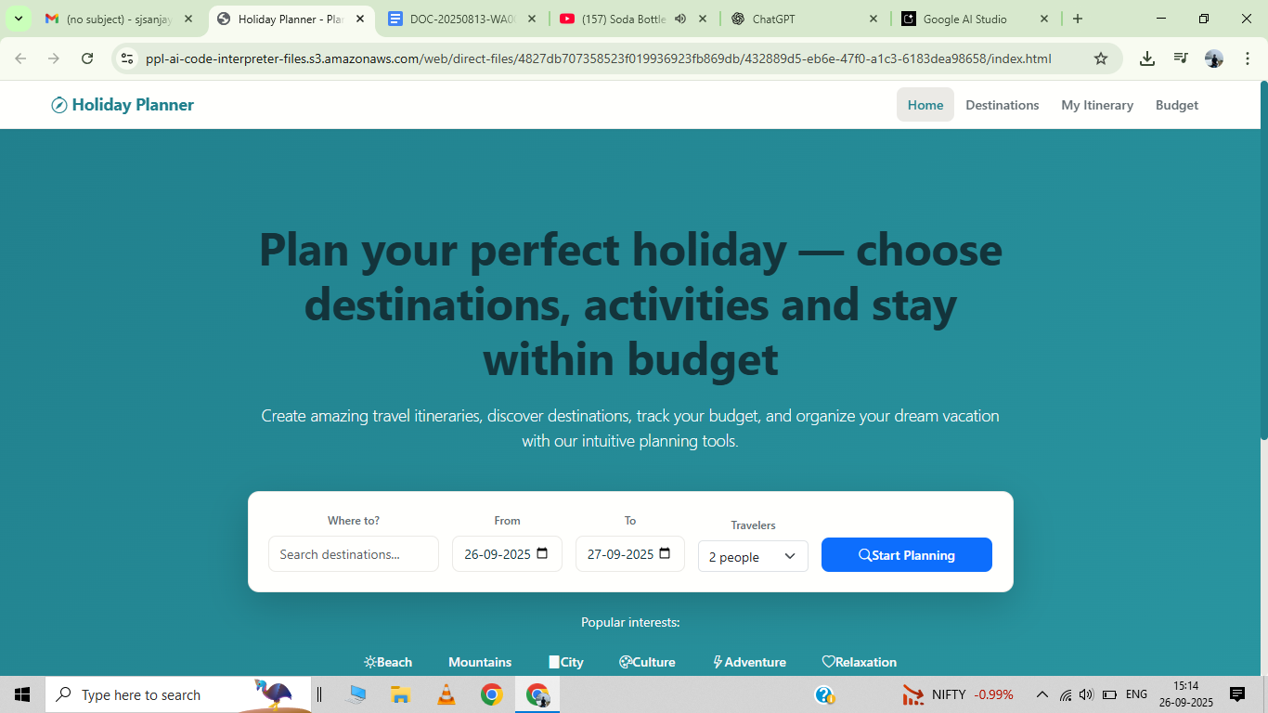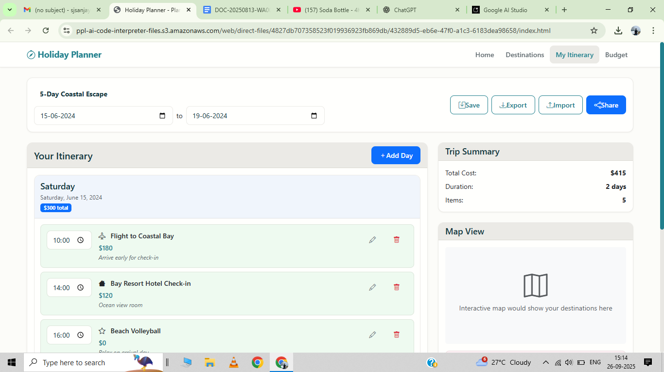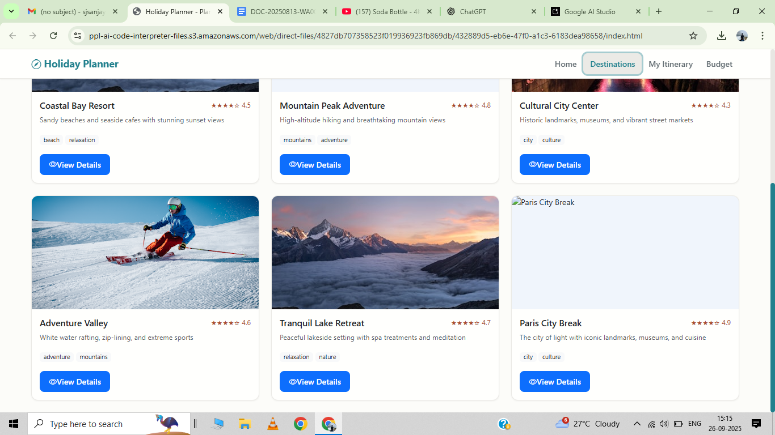

**11. Conclusion**

The Creating Holiday planner project successfully demonstrates the ability to design a clean, modern, and user-friendly website using only HTML,CSS,Java,Bootstrap. The project enhanced our understanding of layout structuring, responsive adjustments, and the importance of branding in web design. By focusing solely on front-end development, we gained practical skills in visual hierarchy, typography, and color usage for a real-world application.

**12. References**

* L&T LMS : <https://learn.lntedutech.com/Landing/MyCourse>

• W3Schools HTML & CSS Documentation

• MDN Web Docs (Mozilla Developer Network)